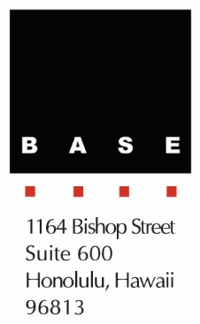
Contact
Serena Humay
Marketing Director
Baldridge & Associates Structural
Engineering, Inc. (BASE)
Phone: 808.534.1300
shumay@baseengr.com

FOR IMMEDIATE RELEASE

FERNANDO FRONTERA NAMED A 2015 RISING STAR IN STRUCTURAL ENGINEERING

HONOLULU, HAWAII – April 24, 2015 – BASE Associate Fernando Frontera was named a 2015 Rising Star in structural engineering by Civil + Structural Engineer magazine. Frontera is the only structural engineer in Hawaii named in the exclusive list that recognizes exceptional structural engineers 40 years old or younger in the United States.

Frontera began his career at BASE in 2006 and holds a Master of Science degree in civil engineering from the University of Michigan-Ann Arbor. His notable projects include the Pearl Harbor Visitor Center, Andaz Maui at Wailea, and The Ritz-Carlton Residences Waikiki Beach currently under construction. He has also developed expertise in Antiterrorism/Force Protection (AT/FP) and is currently the president of the Structural Engineers Association of Hawaii.

Baldridge & Associates Structural Engineering, Inc. (BASE) is an internationally recognized full service structural engineering and forensic consulting firms with offices in Honolulu, Guam, Chicago, and Delhi, India. Projects in its vast portfolio include government, commercial, and residential work. Since its inception, BASE has encouraged the evaluation of each project from the client’s point of view with emphasis on schedule, economy and detail as reflected by the unique needs of the client and their project. This commitment has guided BASE in the successful completion of projects both large and small not only in Hawaii, but also in India, Guam, Korea, the U.A.E., and the U.S. mainland. BASE also operates BASE Testing & Inspection (T&I) and BASE Research & Development (R&D). For more information, please visit www.baseengr.com.

# # #

