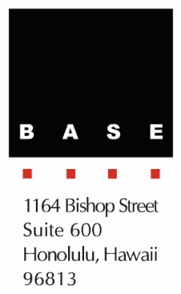
Contact
Steve Baldridge
President
Baldridge & Associates Structural Engineering, Inc. (BASE)
808.534.1300
sb@baseengr.com

FOR IMMEDIATE RELEASE

LOCAL FIRM GOES BOLLYWOOD, BREAKS GROUND ON
1.2 MILLION SF HOTEL IN INDIA

HONOLULU, HAWAII – September 22, 2016 – Honolulu-based Baldridge & Associates Structural Engineering (BASE) recently broke ground on a 1.2 million square foot, $500 million new hotel project in Mumbai, India. BASE is the structural engineer of record for the Maker Maxity Luxury Hotel project being developed by The Indian Film Combine Pvt. Ltd. and constructed by Leighton India, Pvt., Ltd. The project consists of two luxury brand hotels with a total of 475 rooms. Construction is slated to be completed in September 2019.

Some of the unique challenges on the project included designing the building without expansion joints over its 750+ foot length and transferring 20+ floors of hotel over the ballroom. The workaround for no expansion joints was to use strategically placed delayed pour strips and designing the podium for additional seismic forces from out-of-phase behavior of the towers. The ballroom transfer required a visually expressed concrete truss at Level 5 that spans 83 feet between building columns, which required a lot of coordination with the architect and mechanical engineer for aesthetics and functionality.

BASE is currently the structural engineer of record on several large developments in India, the scale of which are much larger than projects typically anything being constructed in Hawaii. BASE has worked on over 20 projects in India since 2009, most notably Wave One in Noida that was topped off in December 2014. Wave One is a 2.6 million square foot, 600-foot tall, 40-story luxury mixed-use high rise that includes parking, a shopping center, multiplex theater, and office space. The structure is unique in that there are two towers atop a 17-story podium and the two towers are joined together at the top eight levels.

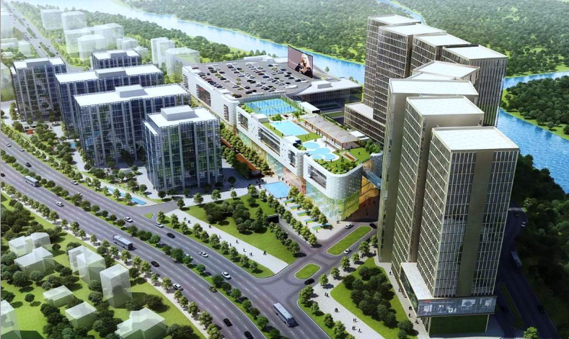
Rendering of the Maker Maxity Luxury Hotel project in Mumbai. BASE is the structural engineer of record for the towers on the right.

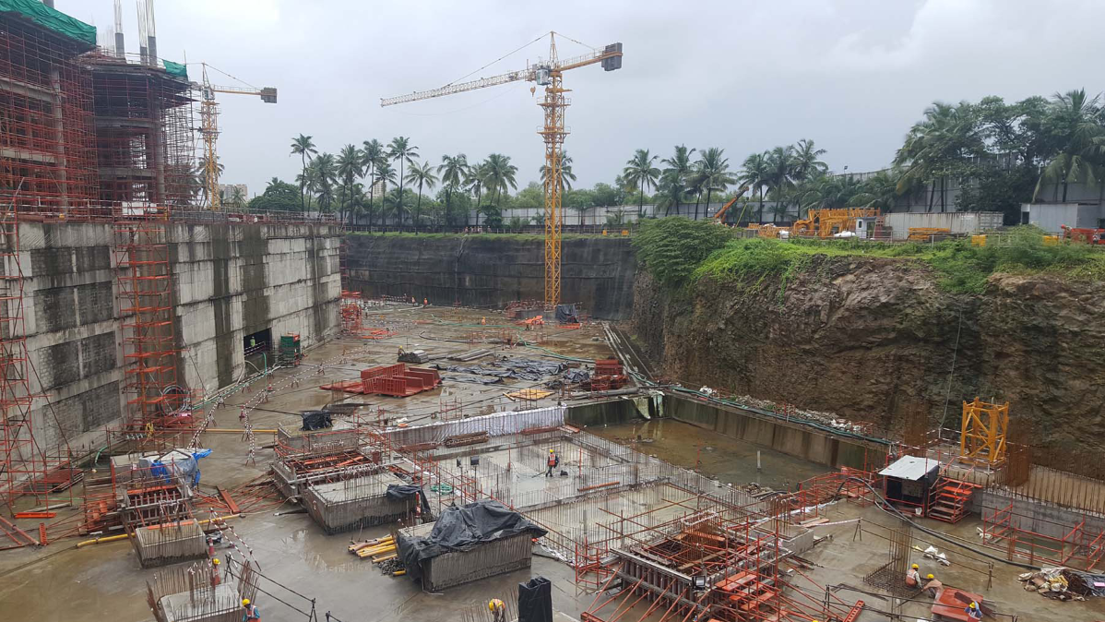
Foundation construction at the Maker Maxity Luxury Hotel project in Mumbai.

Baldridge & Associates Structural Engineering, Inc. (BASE) is an internationally recognized full-service structural engineering and forensic consulting firms with offices in Honolulu, Chicago, Guam, and Delhi. Projects in its vast portfolio include government, commercial, and residential work. Since its inception in 1995, BASE has encouraged the evaluation of each project from the client’s point of view with emphasis on schedule, economy and detail as reflected by the unique needs of the client and their project. BASE also operates BASE Testing & Inspection (T&I) and BASE Research & Development (R&D). For more information, please visit www.baseengr.com.

# # #

