FOR IMMEDIATE RELEASE

AREA ENGINEERING FIRM HITS MILESTONE WITH
5 MILLION-SQUARE-FOOT PROJECT IN INDIA

CHICAGO, ILLINOIS – November 1, 2016 – Hot on the heels of starting construction on a major hotel in Mumbai, India, BASE achieved another milestone in its international work. This month marked the topping off of the 5 million-square-foot Camellias Residential project in Gurgaon, India. The project includes nine towers ranging in height from 300 to 500-feet tall and includes a three-level, 447,870-square-foot basement that includes 1,887 parking stalls for the residences. Topping areas over the basement are 15 acres of extensive landscaping that includes a one-acre lake, mostly located over the basement parking.

This “five star” and LEED Gold project is one of India’s largest residential projects and includes 429 large apartments and 14 expansive luxury penthouses. The apartments are four or five-bedroom units that range in size from 6,750 to 9,300 square feet. The penthouses range in size up to 15,500 square feet, some of which include their own swimming pools. Unit prices range from $3 to $7 million U.S. dollars.

The project boasts some impressive statistics including having poured close to 280,000 cubic-yards of concrete to top out the structure. One of the most impressive statistics relates to project safety, notes BASE President Steven Baldridge. “Topping off was achieved with 27 million man hours with no loss time injury, something difficult to achieve in the U.S., let alone in India. We are particularly proud to be involved with a contractor and a project that puts worker safety as a high priority.”

The project’s contractor, Leighton India Contractors Pvt. Ltd., was faced with several challenges, including expedited construction documents and an aggressive construction schedule. To meet the schedule, Leighton had to find efficiencies in the structure’s construction approach and having worked closely with BASE on previous projects, Leighton enlisted the firm to develop construction documents with sufficient detail to allow for tower foundation work to begin as soon as the site was excavated to the basement level. In order to develop the foundation design, BASE was tasked with completing overall building analysis and BIM models, including the towers, within a short duration of only two months.

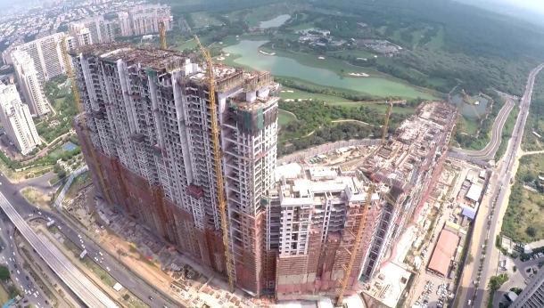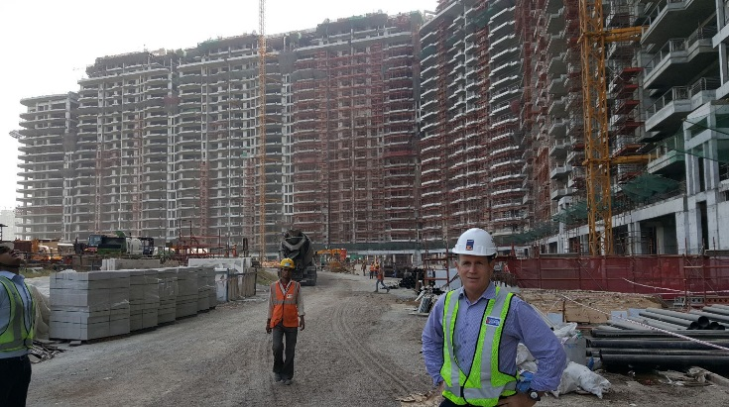
BASE President Steve Baldridge on-site at the 5 million-square-foot Camellias project in Gurgaon, India.
Aerial drone shot of the Camellias construction site.

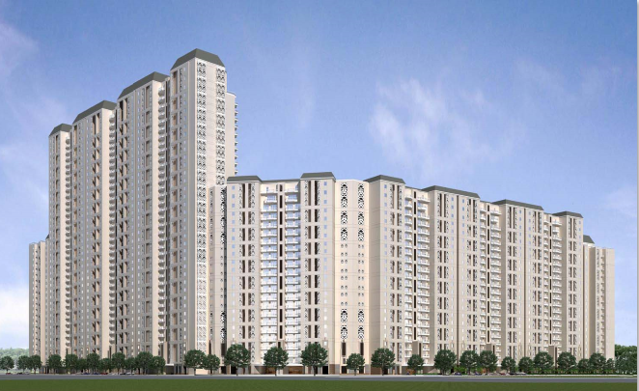
Rendering of the completed Camellias.

Baldridge & Associates Structural Engineering, Inc. (BASE) is an internationally recognized full-service structural engineering and forensic consulting firms with offices in Honolulu, Chicago, Guam, and Delhi. Projects in its vast portfolio include government, commercial, and residential work. Since its inception in 1995, BASE has encouraged the evaluation of each project from the client’s point of view with emphasis on schedule, economy and detail as reflected by the unique needs of the client and their project. BASE also operates BASE Testing & Inspection (T&I). For more information, visit www.baseengr.com.

# # #

