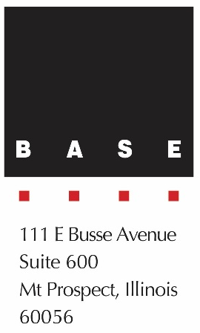
Contact
Anantha Chittur
Senior Associate
Baldridge & Associates Structural
Engineering, Inc. (BASE)
Phone: 312.739.3701
achittur@baseengr.com

FOR IMMEDIATE RELEASE

BASE’S THE RITZ-CARLTON RESIDENCES WAIKIKI BEACH, PHASE 1 WINS TOP POST-TENSIONING INSTITUTE AWARD

MOUNT PROSPECT, ILLINOIS – MAY 1, 2017 – Baldridge & Associates Structural Engineering, Inc. (BASE) has announced that The Ritz-Carlton Residences Waikiki Beach, Phase 1 was awarded 2017 Project of the Year by the Post-Tensioning Institute (PTI). The PTI awards are given biennially and recognizes projects worldwide for excellence in its application of post-tensioned concrete. BASE was the structural engineer of record for this project developed by PACREP, LLC, designed by Guerin Glass Architects, and constructed by Albert C. Kobayashi, Inc.

“We enjoy working with an active structural system such as post-tensioning, so we were very excited to hear our project was recognized with the Project of the Year award from the Post-Tensioning Institute,” said BASE President Steven Baldridge. “With stringent height limitations, long spans and cantilevers, multiple transfer girder and truss requirements all melded into an aesthetically appealing curved building profile, post-tensioning became the choice for this structural, yet artistic composition. There really was no other structural system that could be used to meet this project’s challenging requirements.”

BASE leveraged the talents and staggered time zone of its Chicago and Honolulu offices to meet a demanding project schedule. This included last-minute changes to the building while it was under construction to accommodate the requests of potential buyers.

The awards jury recognized the following key elements:
- The project was encumbered by height limits, numerous easements, and truck maneuvering areas under the building. The only way for the building to meet all project requirements was through the use of post-tensioning.
- To squeeze 38-stories within 350-ft. height limit, the majority of the floors were 7" thick post-tensioned slabs.
- In order to meet the goal of optimizing sellable residential area the podium utilized 17 post-tensioned transfer girders to transfer tower walls and columns onto a different grid of podium and parking level columns and walls.
- The ground floor truck maneuvering areas also had constraints that would not allow the podium’s vertical elements over the loading dock to extend down to the foundation level. The solution to this was a two-story post-tensioned concrete truss spanning 120 ft.
- The penthouse levels were designed with some spectacular large double-story atrium spaces. The atrium openings were achieved by hanging partial floor post-tensioned slabs with steel hanger columns from the roof level. The roof slab not only had to support the loads from the hanging columns, but also the loads from heavy mechanical loads in the center and landscaped rooftop terrace loads on the perimeter. The roof level transfer slab could only be achieved utilizing post-tensioning.

The PTI awards dinner was held on May 1, 2017 in Atlanta, Georgia. Steven Baldridge accepted the award for The Ritz-Carlton Residences Waikiki Beach, Phase 1.

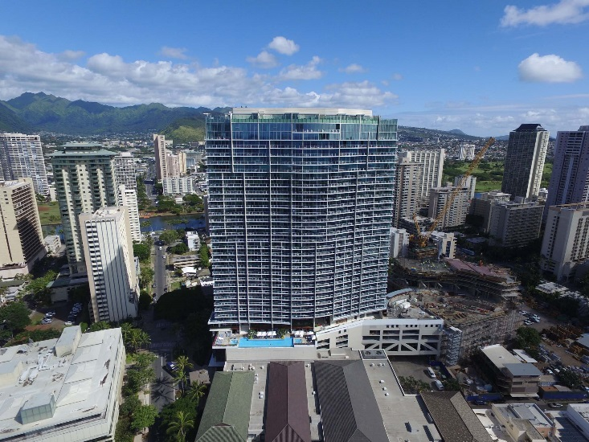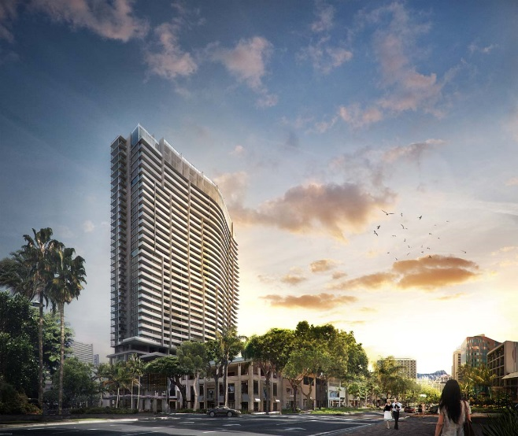
Rendering of The Ritz-Carlton Residences Waikiki Beach, Phase 1. Courtesy of Guerin Glass Architects.
The Ritz-Carlton Residences Waikiki Beach, Phase 1 opened its doors in July 2016.

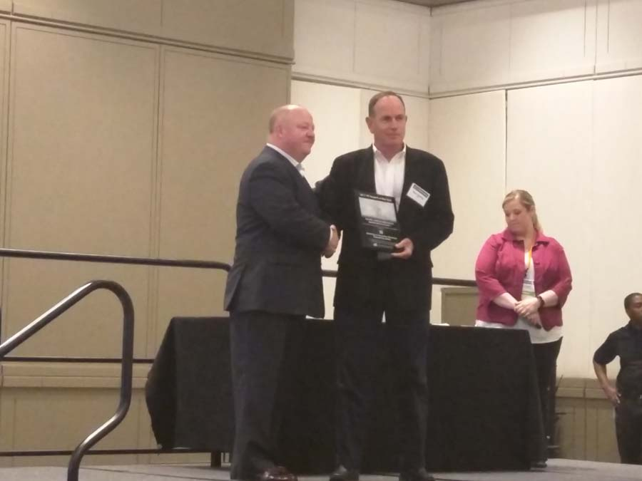
BASE President Steven Baldridge (right) accepting PTI’s 2017 Project of the Year award for The Ritz-Carlton Residences Waikiki Beach, Phase 1.

Baldridge & Associates Structural Engineering, Inc. (BASE) is an internationally recognized full-service structural engineering and forensic consulting firm with offices in Chicago, Honolulu, and Guam. A small business concern, BASE has the resume of larger firms yet provides the personalized service common in smaller firms. Their resume includes a vast array of project types ranging from renovation work to new facilities costing hundreds of millions of dollars. Clients include private and non-profit corporations, as well as county, state, and federal agencies. The number of successful design-build and value engineering projects, and most importantly the resultant savings to clients in cost and schedule, are indicative of BASE’s attention to economy and constructability. For more information, visit www.baseengr.com.

# # #

