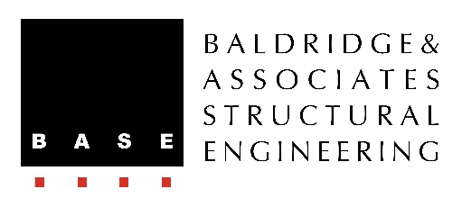
Contact
Steve Baldridge
President
BASE
Phone: 808.534.1300
sb@baseengr.com

1164 Bishop Street, Suite 600
Honolulu, HI 96813

FOR IMMEDIATE RELEASE

LOCAL COMPANY RANKS NUMBER TWO IN
NATIONAL LIST OF BEST FIRMS TO WORK FOR

HONOLULU, HAWAII – JUNE 1, 2018 – Baldridge & Associates Structural Engineering, Inc. (BASE) was recently ranked second in an annual listing of Best Structural Engineering Firms To Work For. The ranking is compiled by Zweig Group, a management consulting firm for the architecture and engineering industries, and recognizes firms for superior achievements in criteria such as workplace practices, quality of management, employee benefits, and employee retention rates.

“To be number two out of thousands of structural engineering firms across North America is truly humbling. We’re honored to be recognized as one of the best structural engineering firms to work for,” said Steve Baldridge, BASE president.

“This year was the most competitive year we have had for Best Firms To Work For! With both first timers and legacy firms in the mix, participation in this award increased for the third year in a row. This is such an important designation right now because the hiring market is so competitive and these firms really stand out from the rest of the industry,” said Kyle Ahern, Awards Manager, Zweig Group.

BASE was founded in Honolulu in 1995 and has since expanded with offices in Chicago, Miami, Guam, and Delhi, India. Its 30+ employees have engineered many of Honolulu’s most prominent projects from the single-story Pearl Harbor Visitors Center to high-rise projects such as 801 South Street, Keauhou Lane, The Ritz-Carlton Residences Waikiki Beach, and Ae‘o in Ward Village.

Baldridge & Associates Structural Engineering, Inc. (BASE) is an internationally recognized full-service structural engineering and forensic consulting firm with offices in Honolulu, Chicago, Miami, Guam, and Delhi, India. A small business concern, BASE has the resume of larger firms yet provides the personalized service common in smaller firms. Clients include private and non-profit corporations, as well as county, state, and federal agencies. For more information, visit www.baseengr.com.

# # #

