Contact
Serena Humay
Marketing Manager
Phone: 808.534.1300
shumay@baseengr.com

FOR IMMEDIATE RELEASE

THE RITZ-CARLTON RESIDENCES WAIKIKI BEACH, PHASE 2
RECOGNIZED FOR STRUCTURAL EXCELLENCE

CHICAGO, ILLINOIS – MAY 10, 2019 – The Ritz-Carlton Residences Waikiki Beach, Phase 2 was recognized with a Post-Tensioning Institute (PTI) Project Award for its exemplary use of post-tensioned concrete to overcome challenging aspects of the project, such as its rotation at the 27th floor to face Hawaii’s famous landmark Diamond Head. The project was designed by the Chicago and Honolulu offices of the structural engineering firm BASE and Guerin Glass Architects was the architect of record.

The Phase 2 tower was designed with a unique geometry requiring “crazy structural gymnastics,” according to Scott Glass of Guerin Glass Architects. As the tower reaches the mean height of approximately 240 feet, the floor plan twists east to face Diamond Head. In order to achieve this a large portion of the floor plan was cantilevered as much as 30 feet beyond the floor plan below, which was done by creating a grid of long span trusses supported at one end by a 3-level cantilevered truss. This structural system was designed to carry 11 occupied floors along with a landscaped penthouse roof deck. The building is topped off with incredible 2-story atriums in the penthouses where floating edges of slabs were supported using posts hung from the roof slab above.

“Structural engineering is one of the few professions where you have the opportunity to defy gravity and you can’t take that lightly,” states Steve Baldridge of BASE. “We went through a lot of effort to track load paths as the structure twists and turns to the meet the project’s functional and aesthetic requirements. The slabs at penthouse atriums appear to float in air and the upper floors hang in the sky but there is a lot of engineering that goes into making that a reality.”

The PTI awards are given biennially and recognizes projects worldwide for excellence in its application of post-tensioned concrete. BASE has designed other PTI award-winning projects including the Phase 1 tower of The Ritz-Carlton Residences Waikiki Beach; Trump International Hotel Waikiki; and the Joint Traffic Management Center Parking Structure.

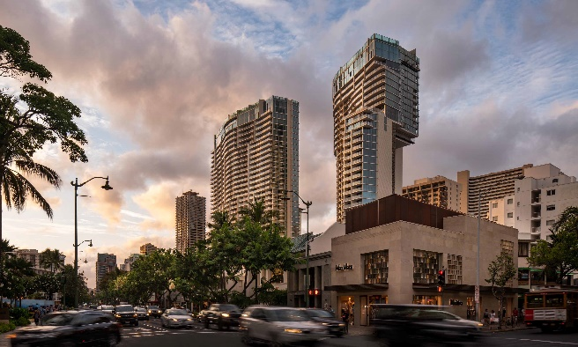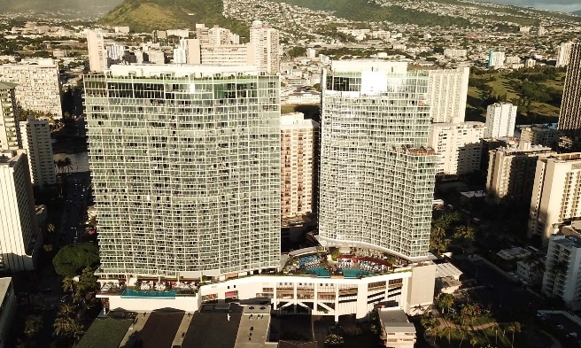
At right, the Phase 2 tower of The Ritz-Carlton Residences Waikiki Beach.
The twisting floor plan can be seen in this photo of the Phase 2 tower (right).

Baldridge & Associates Structural Engineering, Inc. (BASE) is an internationally recognized full-service structural engineering and forensic consulting firm with offices in Chicago, Honolulu, Guam, and India. Known for its diverse expertise, BASE’s resume includes a wide array of project types including residential, commercial, healthcare, hospitality, and national defense projects. For more information, visit www.baseengr.com.

# # #

