Contact
Serena Humay
Marketing Manager
Phone: 808.534.1300
shumay@baseengr.com

1164 Bishop Street, Suite 1600
Honolulu, HI 96813

FOR IMMEDIATE RELEASE

BASE MAKES TOP 10 TWICE IN
NATIONAL LIST OF BEST FIRMS TO WORK FOR

HONOLULU, HAWAII – JULY 1, 2020 – In an annual listing of Best Firms To Work For, BASE ranked fourth in the Structural Engineering category and ninth in the 1-49 Firm Size category. The national ranking is compiled by Zweig Group and recognizes firms for superior achievements in criteria such as workplace practices, firm culture, employee benefits, and employee retention rates. This year marks BASE’s 15th appearance in the list and the only structural firm to make the list 10 years in a row.

“To be number four out of thousands of structural engineering firms across North America is truly humbling. We’re honored to be recognized as one of the best structural engineering firms to work for,” said Steve Baldridge, BASE president.

“With recruitment and retention continuing to be the greatest challenges for firms, this contest, the only national best places to work for the AEC industry, is more important than ever,” said Zweig Group CEO Chad Clinehens. “Add the current pandemic to the mix and it is even more critical for firms to find measurable ways to reinforce their culture and the good things they are doing and creating. Celebrating an award like Best Firms To Work For does just that and infuses positive energy into the environment.”

The complete list of Best Firms To Work For Winners can be accessed here: https://bit.ly/2YMyNX9

BASE has engineered many of Honolulu’s most prominent structures such as The Ritz-Carlton Residences Waikiki Beach and The Pearl Harbor Visitor Center, and projects in Chicago including Avenir, Fulton East, 1125 W Van Buren, and a new barracks at Great Lakes Naval Station.

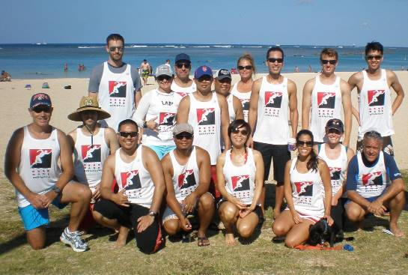

Baldridge & Associates Structural Engineering, Inc. (BASE) was established in 1995 in Honolulu, HI as a full-service structural engineering and forensic consulting firm that has expanded its reach and diversity of design experience with offices Chicago, Florida, Guam, and India. Known for their diverse expertise, BASE has a wide range of project experience including residential, commercial, healthcare, hospitality, and national defense projects. For more information, visit www.baseengr.com.

# # #

